URS SRS Progress 2

The mobile application can get list of all help places in the database.

1. The system shall retrieve list of all help places from database.
2. The system shall show list of all help places in form of JSON.

The mobile application can get the nearest help place by the selected category.

1. The system shall find the nearest help place by the selected category.
2. The system shall show the nearest help place in form of JSON.

The mobile application can get list of help places where locate in the setting scope.

1. The system shall retrieve list of help places where locate in the setting scope from the database.
2. The system shall show list of help places where locate in setting scope in form of JSON.

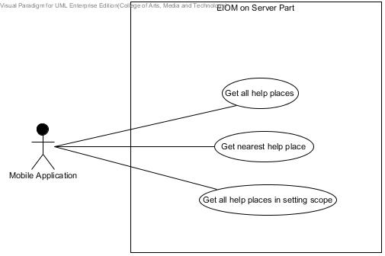

**UC-0X:** Get list of all help places

The mobile application can get list of all help places in the database.

**Actor**

Mobile application

**Prerequisite**

The mobile application requests to get list of all help places.

**Input**

-

**Output**

System shows list of all help places in database in JSON form.

**Flow of Execution**

1. The mobile application requests to get list of all help places.
2. The system retrieves list of all help places from database.
3. The system shows list of all help places in form of JSON.

**UC-0X:** Get nearest help place

The mobile application can get the nearest help place by the selected category.

**Actor**

Mobile application

**Prerequisite**

The mobile application requests to get nearest help place.

**Input**

The identity number of selected category.

Latitude of the mobile application’s current location.

Longitude of the mobile application’s current location.

**Output**

System shows nearest help place in JSON form.

**Flow of Execution**

1. The mobile application requests to get nearest help place.
2. The system finds the nearest help place by the selected category.
3. The system shows the nearest help place in form of JSON.

**UC-0X:** Get list of all help places in setting scope

The mobile application can get list of help places where locate in the setting scope.

**Actor**

Mobile application

**Prerequisite**

The mobile application requests to get list of help places where locate in the setting scope.

**Input**

The meter number of setting scope.

Latitude of the mobile application’s current location.

Longitude of the mobile application’s current location.

**Output**

System shows list of help places where locate in setting scope in JSON form.

**Flow of Execution**

1. The mobile application requests to get list of help places where locate in the setting scope.
2. The system retrieves list of help places where locate in setting scope from the database.
3. The system shows list of help places where locate in setting scope in form of JSON.

Get nearest help place

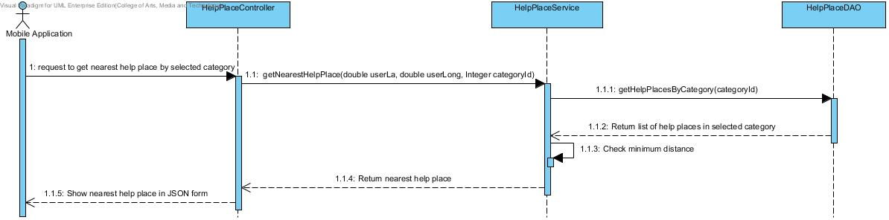

Get all help places

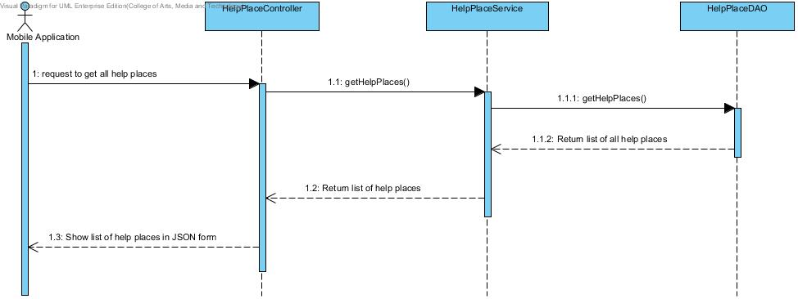

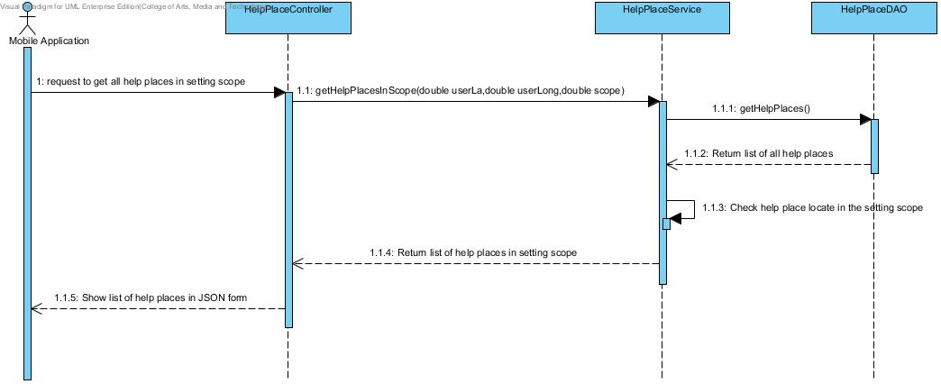Get all help places in setting scope